Rose to Carmen
Project IT Spec Handoff and Go-Live Onboarding
CollabOS Command Center (RoseOS) · Clean-source handoff · Not a go-live approval
SCOPE OF THIS DOCUMENT
This GitHub push is NOT approval to go live. It is NOT approval to redesign. It is NOT approval to change features. It is NOT approval to connect production data or live services.
Carmen must review the technical wiring. Rose must approve any design/function change and the final live launch. Rose's private code word must never be documented, repeated, stored, or shared.

1. Project Overview
CollabOS Command Center (internal name: RoseOS Collab Command Center) is a collaboration-intelligence internal operating system for two founders — Rose and Carmen — and their team. It helps them align on ideas, surface duplicate work, route decisions through a central approval queue, and synthesize their two perspectives in a private Mind Meld Room.
Architecture is hybrid: authentication, user management, audit logs, and the Mockup Studio are REAL backend features (Express + PostgreSQL, sessions verified per request, permissions enforced server-side). All other modules are local-first — seeded data persisted in the browser (localStorage).

2. Repository, Branch, Commit & Version
GitHub repo (HTTPS) | https://github.com/contractorcomplianceco-cmyk/collabos
GitHub repo (SSH) | git@github.com:contractorcomplianceco-cmyk/collabos.git
Target branch | main (overwrite/replace approved by Rose)
Prepared commit hash | 5f56fdb0fea93b613cc05fdb43ec43f1264d5b27
Version ID | 2026-07-06-collabos-clean-main-v1
Push status | NOT YET COMPLETED — blocked on GitHub write auth (see §18 & §21)
Target repo state | Empty at time of prep (no existing branches) — clean overwrite, zero conflict

3. Source Project URL
- Replit workspace (dev/source): https://b3dab650-36c8-4d93-92da-1d901a680e3b-00-ygrvm6pfnpx.worf.replit.dev
This is the single source of truth for the clean newest version.

4. Temporarily Published Latest-Version Link
- https://rose-os-command-center.replit.app/
Reviewed and visually confirmed during this handoff (see §5 and §19).

5. Visual Confirmation
The published link was opened and confirmed to be the correct, current CollabOS Command Center build — secure sign-in screen with the CollabOS logo, role-based demo accounts, and the 'Sessions are verified on every request' / 'Every important action is written to the audit log' assurances. Full screenshot embedded in §19.

6. What Was Pushed (Clean Source)
- Application source: artifacts/ (roseos frontend, api-server backend, mockup-sandbox), lib/ (shared db + libraries), scripts/
- Config: tsconfig.json, tsconfig.base.json, pnpm-workspace.yaml, .replit, .replitignore, .gitignore, .npmrc
- Manifests: package.json + pnpm-lock.yaml (pnpm lockfile)
- Docs: replit.md (project overview + architecture)
- attached_assets/: development-time screenshots and pasted planning notes (contain NO secrets and NO code word) — flagged as an open question in §22
Total tracked files: 267. No secrets, no .env files, no local databases included.

7. What Was Intentionally Excluded
- node_modules/ (dependencies — reinstalled via pnpm install)
- dist/, tmp/, out-tsc/, *.tsbuildinfo (build outputs & TS cache)
- .cache/, .local/ (Replit + local-only files)
- coverage/, logs, .DS_Store, IDE/editor folders
- .env files, secrets, API keys, tokens (never committed)
- Local databases, exports, stale prototype build folders
Verified: .gitignore covers dependencies, build outputs, caches, secrets, and local-only files. A tracked-file scan found zero .env/secret/key/db/dump/credential files.

8. Build & Start Commands
Install | pnpm install
Typecheck (all) | pnpm run typecheck
Build (all) | pnpm run build
API server (dev) | pnpm --filter @workspace/api-server run dev (builds + starts, port 5000)
Frontend (dev) | pnpm --filter @workspace/roseos run dev (Vite)
Frontend tests | pnpm --filter @workspace/roseos run test (53 passing)
DB schema push | pnpm --filter @workspace/db run push (dev only)
API codegen | pnpm --filter @workspace/api-spec run codegen

9. Framework, Package Manager & Runtime
Runtime | Node.js v24.13.0
Package manager | pnpm 10.26.1 (pnpm workspaces monorepo; lockfile pnpm-lock.yaml)
Language | TypeScript 5.9 (strict)
Frontend | React + Vite (SPA), wouter routing, Tailwind, lucide-react icons
Backend | Express 5 (REST under /api)
Database / ORM | PostgreSQL + Drizzle ORM
Validation / codegen | Zod (zod/v4), drizzle-zod, Orval (OpenAPI → hooks/schemas)
Backend build | esbuild (CJS/ESM bundle)

10. Required Environment Variables (values redacted)
DATABASE_URL | **** REDACTED **** — PostgreSQL connection string (required)
SESSION_SECRET | **** REDACTED **** — signs/verifies session cookies (required)
No other secrets are required for current functionality. These must be set in the target environment; they are NOT committed to the repo.

11. Authentication Status
REAL and working. Email/password login with bcrypt-hashed passwords, database-backed session tokens, and cookie sessions verified on every request. Logout invalidates the session server-side.

12. Database & Storage Status
- Database: REAL — Replit-managed PostgreSQL via Drizzle ORM. Tables: users, sessions, mockups, mockupVersions, auditLogs.
- Object/file storage: NOT configured (no uploads/object storage in use).

13. API & Integration Status
- Internal REST API: REAL — Express under /api (auth, users, audit logs, mockups).
- External Intake (Zoho Cliq / WhatsApp): TEST-MODE ONLY — frontend simulation with honest 'test mode' labeling. Live mode is disabled. No live external connection exists.

14. Email / SMS / Payment / AI Status
- Email: NOT connected.
- SMS: NOT connected.
- Payments: NOT connected.
- AI / LLM: NOT connected — all 'AI-style' recommendations are rule-based and honestly labeled as such (no generative model is wired).

15. What Is Real vs Simulated / Demo / Sample

Real (server-backed, enforced)
- Authentication & session management
- 7-role RBAC (founder_admin ×2, super_admin, leadership_reviewer, contributor, viewer, guest) — enforced server-side
- User management (CRUD + reset password)
- Audit logs (server-written)
- Mockup Studio (persisted: CRUD, versions, status transitions, dual Rose+Carmen approval)

Simulated / local-first (seeded, browser localStorage 'roseos_state_v1')
- Dashboard, Duplicate Radar, Team Pulse, Solution Finder, Innovation Lab, Executive Reports, Market Pulse, Mind Meld Room, Review Queue, Settings, External Intake
- All seed data (people, projects, ideas, recommendations, market signals, etc.)

Demo accounts
- 7 seeded demo logins (rose@collabos.demo, carmen@, admin@, lena@, devon@, viewer@, guest@) shown on the login page and labeled as demo credentials — must be replaced before go-live.

16. What Still Needs To Be Wired
- Server-side persistence for local-first modules if multi-user shared state is required (currently per-browser).
- Live external intake (Zoho Cliq / WhatsApp) — currently test-mode only.
- Real AI/LLM provider if generative features are ever desired (currently rule-based).
- Email/SMS/payments — none connected.
- Production secrets (DATABASE_URL, SESSION_SECRET) in the target environment.
- Replace demo accounts with real users and strong passwords.

17. What Needs To Be Connected & How
- GitHub write access: connect the GitHub account to the Replit project (Git pane / GitHub integration), then push main. Direct push from the build environment failed because no write token/OAuth is configured (GitHub does not accept password auth).
- Production database: provision Postgres in the target/production environment and set DATABASE_URL.
- Session secret: set SESSION_SECRET in production.
- External intake (future, requires Rose approval + code word): wire Zoho Cliq / WhatsApp webhooks and switch integration mode from test to live.

18. Domain / DNS / SSL / Live Hosting Status
Current hosting | Replit (published)
Live URL | https://rose-os-command-center.replit.app/ (HTTPS/SSL handled by Replit)
Custom domain | None configured
DNS changes | None made
GitHub push | NOT completed — awaiting GitHub connection (see §17 & §21)

19. Screenshot Evidence
Home / Secure Sign-In screen — https://rose-os-command-center.replit.app/
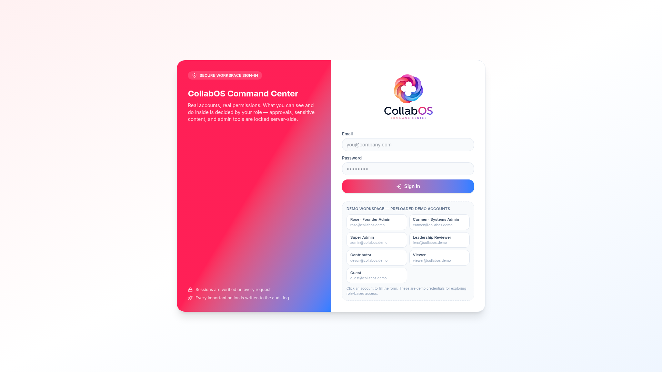
Note: inner screens (dashboard, modules) are auth-gated by design — they are only reachable after a verified login, which is itself confirmation that access control is enforced.

20. Version Marking
Project name | CollabOS Command Center (RoseOS Collab Command Center)
Source project URL | https://b3dab650-36c8-4d93-92da-1d901a680e3b-00-ygrvm6pfnpx.worf.replit.dev
Published latest link | https://rose-os-command-center.replit.app/
GitHub repo | https://github.com/contractorcomplianceco-cmyk/collabos
Branch | main
Commit hash | 5f56fdb0fea93b613cc05fdb43ec43f1264d5b27
Version ID | 2026-07-06-collabos-clean-main-v1
Date prepared | 2026-07-06
Prepared by | Rose
Approval status | Clean handoff to Carmen — NOT live approval

21. Known Risks & Blockers
- BLOCKER: GitHub push not completed — no write credentials in the build environment. Must be pushed via Replit's GitHub connection.
- Demo accounts use known demo passwords — a security risk until replaced.
- Most module state is local-first (per-browser localStorage), not shared server state.
- External intake is test-mode only — must not be represented as a live integration.
- Production env vars (DATABASE_URL, SESSION_SECRET) must be set in the target environment.
- attached_assets/ contains dev-time screenshots and planning notes (no secrets/no code word) — may be undesirable in a pure source tree.

22. Open Questions for Rose
- Should attached_assets/ (dev screenshots + planning notes) be stripped from the repo for a pure source tree? (separate approved change)
- Is a custom domain intended? (currently replit.app only)
- Which services, if any, should be wired live at launch — and when?
- Should local-first modules be migrated to server persistence for multi-user use?

23. Carmen Onboarding Checklist
- ☐ Accept access to the GitHub repo and confirm main reflects version 2026-07-06-collabos-clean-main-v1
- ☐ Clone the repo and run: pnpm install
- ☐ Set DATABASE_URL and SESSION_SECRET in a local/staging environment
- ☐ Run pnpm run typecheck and pnpm --filter @workspace/roseos run test (expect 53 passing)
- ☐ Start api-server and roseos; log in with a demo account to verify auth + RBAC
- ☐ Review server routes under /api (auth, users, auditLogs, mockups)
- ☐ Review which modules are real vs local-first (see §15)
- ☐ Confirm no secrets are present in the repo

24. Go-Live Readiness Checklist
- ☐ GitHub push completed and main verified
- ☐ Demo accounts replaced with real users + strong passwords
- ☐ Production DATABASE_URL and SESSION_SECRET set
- ☐ Database schema pushed to production (pnpm --filter @workspace/db run push equivalent)
- ☐ Decision on local-first vs server persistence per module
- ☐ External integrations reviewed — kept test-mode unless Rose approves live
- ☐ Custom domain / DNS / SSL decided (if any)
- ☐ Rose's explicit approval for go-live (with private code word)

25. Rose Approval & Code-Word Guardrails
No changes to design, copy, layout, features, workflows, data structures, routing, integrations, dependencies, or architecture may be made without Rose's explicit permission AND her private code word.
- Rose's code word is private. It must NEVER be documented, repeated, displayed, logged, stored, committed, screenshotted, or shared — including in this document.
- For this handoff push only, Rose explicitly waived the code-word step (acknowledging it cannot be kept private in the current chat). This waiver applies to THIS push only and to nothing else.
- This document confirms: no design or function changes were made; no old data was brought over; the push (once completed) contains only the newest clean source version.

END OF HANDOFF DOCUMENT

